COMPUTER PROJECT 2008-09

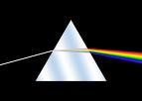
STAR . WAVE

VERSION 1.0
* * * * * * * * * * * * * * *
DEVELOPED BY
NAGABHARAN.N
VINAY A IYER

( CLASS XI )
SRI KUMARAN CHILDRENS HOME, CBSE

